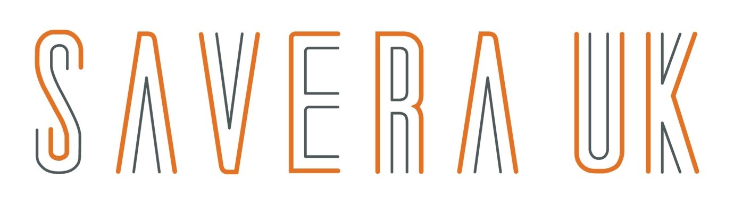

Advisory Board Member Application
CV required with this application

Thank you for your interest in serving as a member of the Savera UK Advisory Board. Being an Advisory Board member is a rewarding experience and an opportunity to support and be part of the organisation’s development and growth.

Please return the completed application with your up to date CV to info@saverauk.co.uk

This application will be kept confidential and on electronic file. Applications are used by the Board and Management to review your skills required as a potential Advisory Board candidate.

Advisory Board Responsibilities:
- Serves a minimum of one year as Advisory Board Member
- Provide guidance and advice to Savera UK in your field of expertise
- Be a resource for our board and team
- Challenge our board and team with the aim of improving our services
- Support the exploration of new ideas to support the charity’s growth
- Attend up to two advisory board meetings and one away day each year

Savera UK:

Vision
To eliminate ‘honour-based’ abuse and harmful practices across the UK and beyond

Mission
To tackle the causes and effects of honour-based abuse and harmful practices by provide one to one support for victims and those at risk, deliver and provide consultancy, training, raise awareness as well partnership collaboration and contacting research

Values

- Empowering
- Collaborative
- Approachable
- Respectful
- Ambitious
- Leadership
- New Beginning

Personal Information:

Name: …………………………………………………………………………………………
Address: ………………………………………………………………………………………
Telephone: …………………………………………………………………………………...
Email: …………………………………………………………………………………………

Work history:

Current work position: ………………………………………………………………………...

Education:…………………………………………………………………………………………………………………………………………………………………………………………...

Work History: …………………………………………………………………………………..
…………………………………………………………………………………………………...

Advisory Board Questions:

Briefly describe why you would like to join Savera UK Advisory Board.

…………………………………………………………………………………………………...…………………………………………………………………………………………………...

Describe the skills and experiences that you would like to contribute as a member of the Advisory Board.
…………………………………………………………………………………………………...…………………………………………………………………………………………………...

How much time are you able to offer the organisation, once you become a member of the Advisory Board?
…………………………………………………………………………………………………...…………………………………………………………………………………………………...

How best can the Savera UK Board and Team liaise and communicate with you when your advice and support required?

…………………………………………………………………………………………………...…………………………………………………………………………………………………...

References:
The work of Savera UK is very sensitive and highly confidential. Please provide details of two references (who are not relatives) who have known you for at least two years.

1. Name ………………………… 2. Name …………………………...
Address …………………… Address………………………….
Tel …………………………. Tel ……………………………

How does this person know you? How does this person know you?
…………………………………... …………………………………...
How long have they known you? How long have they known you?
…………………………………... ………………………………….......

Criminal conviction(s):
Savera UK Board Directors have legal and ethical responsibilities for the governance of the charity and are the accountable body. Please provide details of any convictions or cautions, we need to know about. This would not affect your application in becoming an Advisory Board Member and your application still be considered:

…………………………………………………………………………………………………...…………………………………………………………………………………………………...

DECLERATION:
I declare that the information I have provided on this form is correct to my knowledge. I agree to Savera UK conducting relevant checks to establish my suitability as a voluntary Advisory Board member and for the results of checks to be disclosed to appropriate personnel. I understand the need for confidentiality in line with Savera procedures.

Signed ……………………………….
Print Name ………………………….
Date …………………………………

